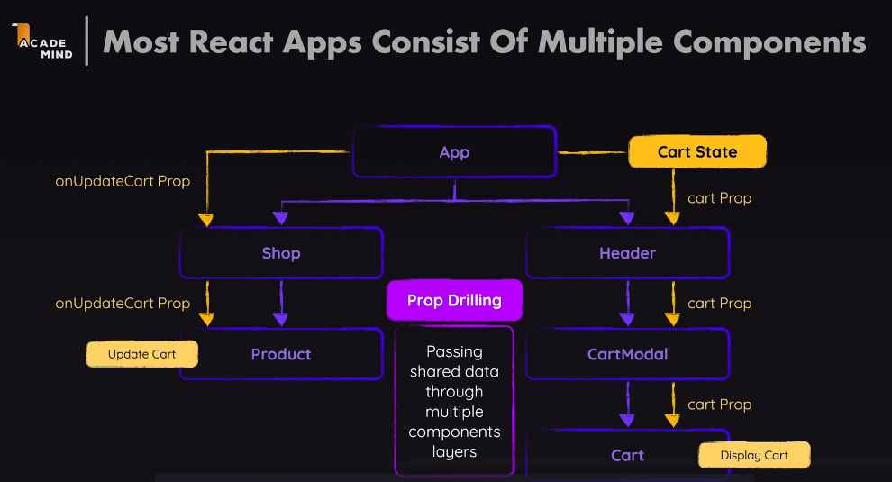

Prop drilling solution: component composition: look at lecture 166 prop drilling

Context API

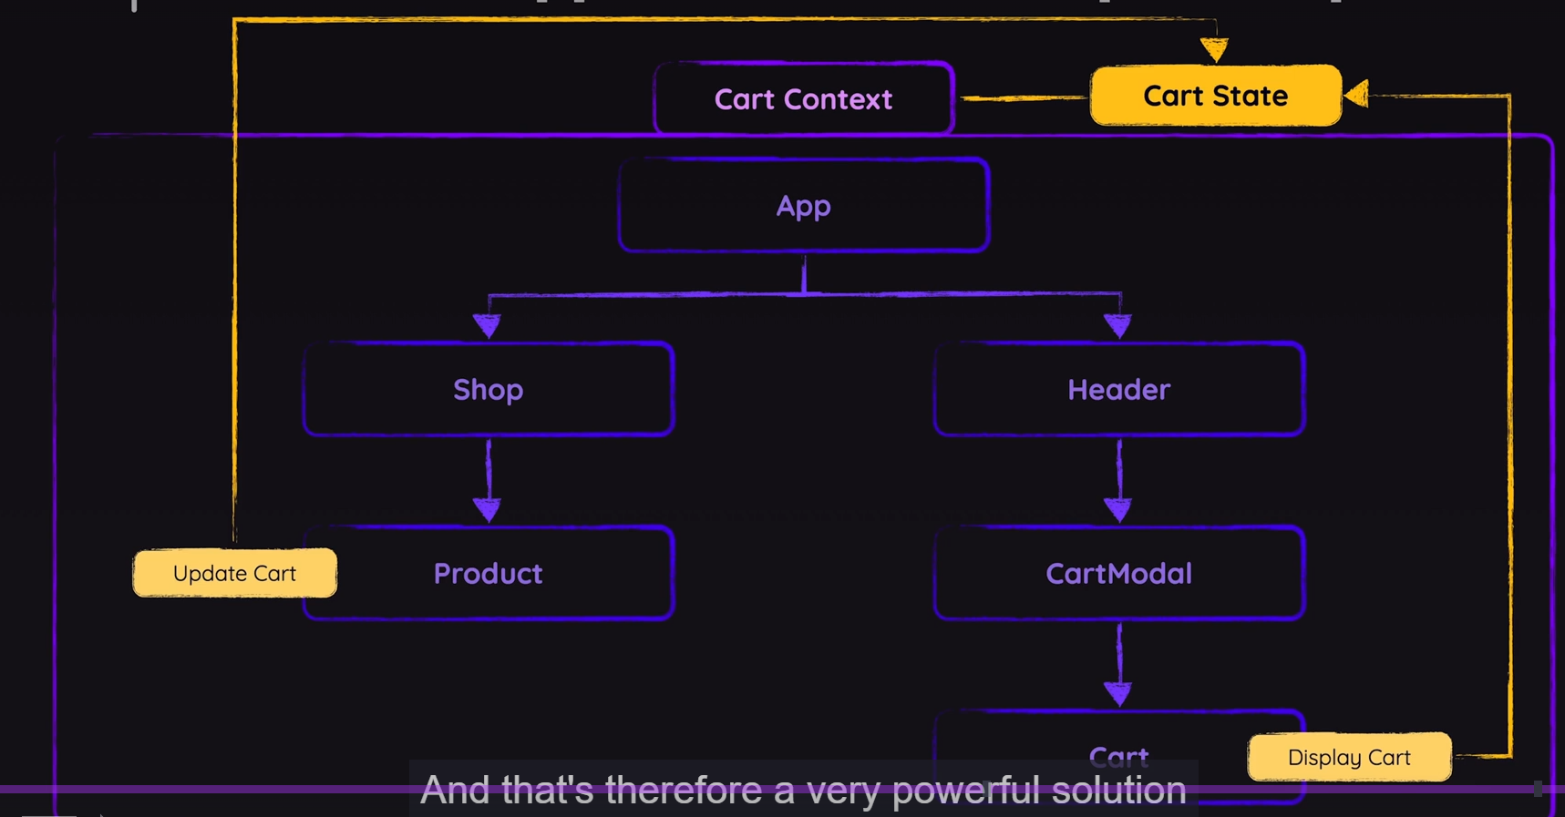Wrap all component with a share context, then states can also share the context

useContext() and use() are the same for grabbing the context API content, but use() could be used inside an if-else:

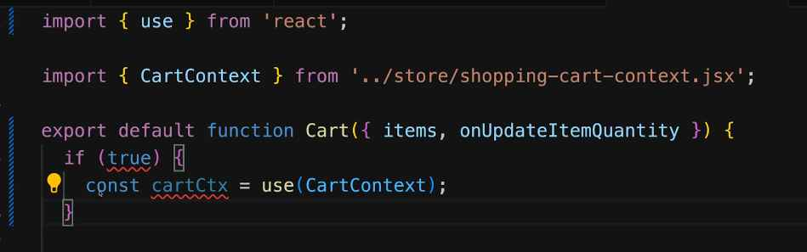

And then wrap it outside of any components that need access:

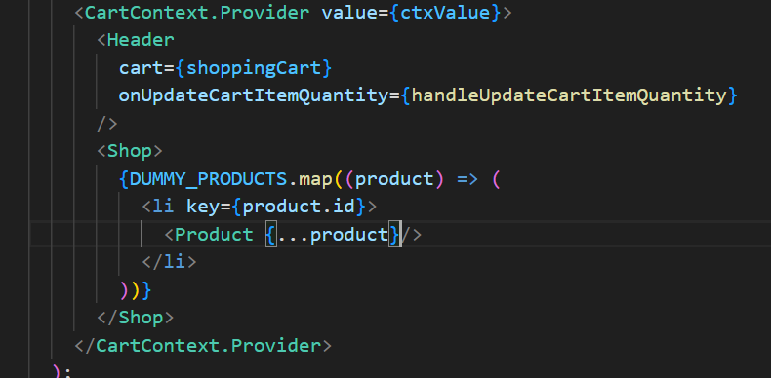

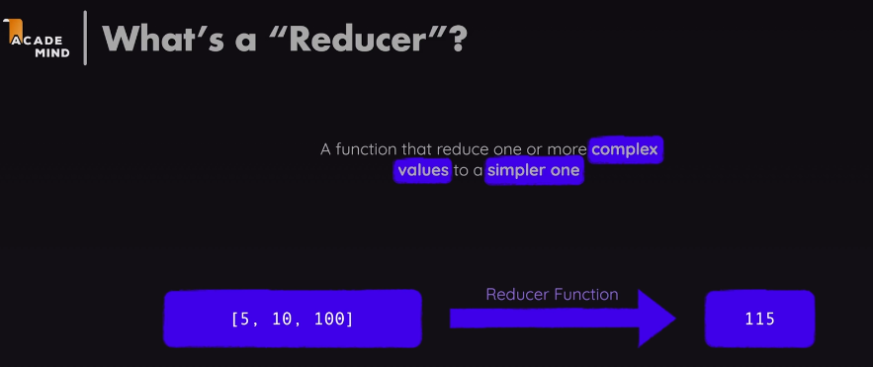

It’s like call user function in Nysus PHP, we will define the action name and do bunch of logic in the background, not inside the component

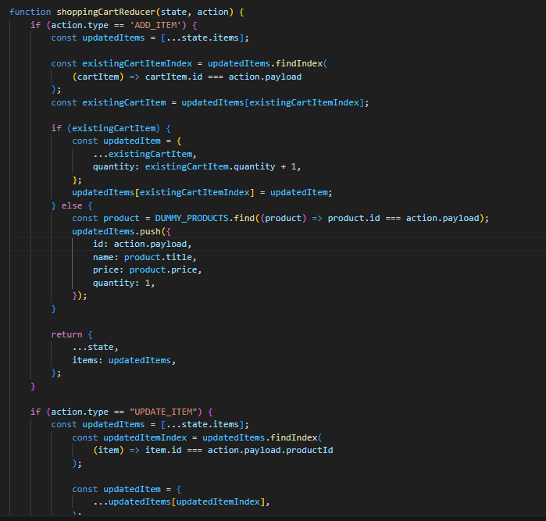

First we will define useReduce with dispatch function and initial value, then we define which dispatch function will be used for which handle

